B.VOC CORE I MANUAL
SHANTHIGRACE IJJINI
M.SC FISHERIES SCIENCE

Catla Catla (Bhakur):
Classification:
Phylum: Chordata
Subphylum: Vertebrata
Superclass: Pisces
Class: Osteichthyes
Order: Cypriniformes
Family: Cyprinidae
Genus: Catla
Species: Catla
Distribution:
It is found in Pakistan, India, Bangladesh, Nepal and Myanmar. It has been introduced recently into Sri Lanka & China. Within India, the species is native to North India & now recently introduced in Peninsular India especially in the river Cauvery.
Habitat:
This species mainly inhabits rivers & can be easily cultured in ponds and lakes. The catla is non-predatory and its feeding is restricted to the surface & mid-waters. This characteristic enables this fish to culture with Rohu & main in the same pond. It breeds in rivers during monsoon. In South India, however, the breeding season is variable.
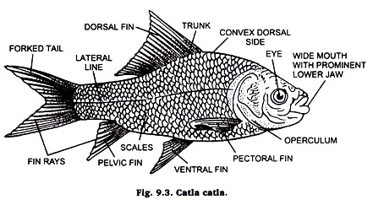
Comments:
1. Pigmentation greyish on dorsal side and silvery on side and abdomen. Fins dark black. Dorsal profile convex.
2. Scales moderate with six and half rows between lateral line and the base of ventral fin.
3. Body divided into head, trunk and tail.
4. Head contains mouth and eyes.
5. Eyes found in the anterior half of the head. Mouth wide with prominent lower jaw.
6. Barbels absent.
7. Dorsal fin slightly more advanced than ventral fin. Pectoral fin located behind ventral fin which does not extend up to the anal fin. Anal fin extending up to the base of caudal fin.
8. Lateral line is complete originating from the upper margin of the gill cover.
Economic importance:
The catla is one of the well-known and fastest growing of the Indian major carps. It is considered an excellent table fish when it is of moderate size. In experimental farms the yield can be as much as ten tonnes per hectare per year.

- Labeo Rohita (Rohu):

Classification:
Division: Gnathostomata
Phylum: Chordata
Subphylum: Vertebrata
Superclass: Pisces
Class: Osteichthyes
Subclass: Actinopterygi
Superorder: Teleostei.
Order: Cypriniformes
Distribution:
Labeo rohita is widely distributed in tropical and temperate regions specially found in India (Punjab, Assam) and Burma, Eocene to Recent.
Habit and habitat:
Labeo rohita is abundantly found in ponds and rivers. Carps are vegetarian and bottom feeders. They can occasionally feed on animal diet. Because of its feeding habit, it is cultivated with two other carps, Catla catla and Cirrhina mrigala. Rohu breeds only in the river and bund type of tanks but not in confined waters.
CHARACTERS:
1. Labeo rohita is commonly known as carp and Rohu in Hindi.
2. Head is depressed and is produced into a short, obtuse and blunt snout. It bears a sub terminal fringe-lipped mouth bounded by fleshy upper and lower lips. It also contains paired nostrils and paired eyes.
3. A pair of filamentous barbels arises from upper lip. Small tubercles cover the snout, which is oblong, depressed, swollen and projecting beyond the jaws.
4. Large operculum hangs on either side enclosing gills and branchial chamber.
5. Lateral line is distinct. Scales overlying the lateral line are perforated by tubes of the lateral line system. Scales are of taxonomic value. Scales are flat, bony with rounded edges and are called as cycloid scales. These overlap and form a complete covering.
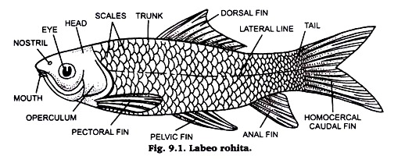
Economic importance:
Labeo has great food value. Its flesh is rich in proteins & minerals & very delicious. It consists of common man’s food especially in West Bengal it is considered very auspicious. For culture purpose it is very preferable fish. It attains about 1 meter length and weighs about 4 kg within two years

. Cirrhinus mrigala (Nain):
Classification:
Phylum: Chordata
Subphylum: Vertebrata
Superclass: Pisces
Class: Osteichthyes
Order: Cypriniformes
Family: Cyprinidae
Genus: Cirrhinus
Species: mrigala
Distribution:
It is found in Pakistan, Bangladesh, Myanmar and India. In Northern India its natural habitat is in the stretch from the Punjab to West Bengal and Assam. It is widely distributed in India due to its introduction all over the country for fishery purposes.
Habit & habitat:
It usually prefers to inhabit rivers and tanks. In thrives best at altitudes less than 600 m and in places where the minimum water temperature does not drop below 14°C. It has been widely introduced into reservoirs and river systems and it can tolerate high levels of salinity. Breeding usually takes place during the monsoon in the shallow margins of rivers, tanks and also in canals.
Comments:
1. Commonly called as Nain.
2. Fish measures 16 to 26 cm in length.
3. Colouration silvery dark grey on dorsal side and whitish on abdomen.
4. Golden coloured eyes located in anterior half of the head in inter orbital width.
5. Various fins are dorsal, ventral, pectoral, pelvic and caudal. Dorsal fin slightly concave.
6. Pectoral fin contains 18 rays.
7. Caudal fin deeply forked.
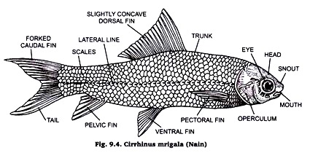
Economic importance:
Owing to its large size Mrigal is popular as a food fish & hence has been introduced all over India. One of the main centres of breeding & hybridization of the species is the Central Inland Fisheries Research Institute, Barrack pore. Its trade name is “Red tailed Grass Carp

TILAPIA
Scientific name: Tilapia
Phylum: Chordata
Higher classification: Cichlid
Order: Cichliformes
Rank: Genus

- Tilapia typically have laterally compressed, deep bodies.
- Like other cichlids, their lower pharyngeal bones are fused into a single tooth-bearing structure.
- A complex set of muscles allows the upper and lower pharyngeal bones to be used as a second set of jaws for processing food (cf. morays), allowing a division of labor between the "true jaws" (mandibles) and the "pharyngeal jaws".
- This means they are efficient feeders that can capture and process a wide variety of food items.^{[11]} Their mouths are protrusible, usually bordered with wide and often swollen lips. The jaws have conical teeth.
- Typically, tilapia have a long dorsal fin, and a lateral line which often breaks towards the end of the dorsal fin, and starts again two or three rows of scales below.
- Some Nile tilapia can grow as long as 2.0 ft.
.
- Tilapia are also known to be a mouth-brooding species, which means they carry the fertilized eggs and young fish in their mouths for several days after the yolk sac is absorbed. 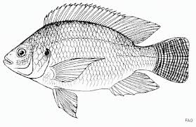

Hypophthalmichthys molitrix
Kingdom: Animalia
Phylum: Chordata
Class: Actinopterygii
Order: Cypriniformes
Family: Cyprinidae
Subfamily: Xenocyprinae
Genus: Hypophthalmichthys
Species: H. molitrix
Common name: Silver Carp
Identification:
- The silver carp is a deep-bodied fish that is laterally compressed.
- They are a very silvery in color when young and when they get older they fade from a greenish color on the back to silver on the belly.
- They have very tiny scales on their body but the head and the opercles are scaleless.

- They have a large mouth without any teeth in the jaw, but they have pharyngeal teeth. Its eyes are situated far forward on the midline of the body and are slightly turned down.
- Silver carp are unlikely to be confused with native cyprinids due to size and unusual position of the eye.
- They are most similar to bighead carp (H. nobilis) but have a smaller head, and upturned mouth without teeth, a keel that extends forward past pelvic fin base, lack the dark blotches characteristic of bighead carp and have highly branched gill rakers.
- Juvenile fish lack spines in fins.
- Metalarvae and early juvenile are similar to bighead carp (Hypophthalmichthys nobilis) but pectoral fin extends only to base of pelvic fin (as opposed to beyond in the pelvic fin in bighead)
- Size: 1 m and 27 kg. 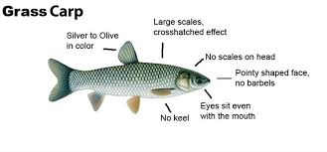
Ctenopharyngodon
Common name: Grass Carp
Kingdom: Animalia
Phylum: Chordata
Class: Actinopterygii
Order: Cypriniformes
Family: Cyprinidae
Subfamily: Squaliobarbinae
Genus: Ctenopharyngodon
Species: C. idella
Identification: Grass Carp is a large member of the minnow family with a body which is moderately compressed laterally.
Its mouth is terminally located on a wide head and eyes are small and low on the head.
It lacks barbels.
It is olive-brown on the dorsal side, with silver sides and a white belly. Scales are large with dark edging.
The dorsal fin origin is anterior to the pelvic fin origin and it has a short caudal peduncle.
It differs from goldfish (Carassius auratus) and common carp (Cyprinus carpio) in having a shorter dorsal fin (only 7-8 rays) and from Hypophthalmichthys species (Bighead and Silver carps) in having fewer anal rays (9 or fewer) and fewer but larger lateral scales.
Size: 125 cm.
COMMON CARP

Kingdom: Animalia
Phylum: Chordata
Class: Actinopterygii
Order: Cypriniformes
Family: Cyprinidae
Subfamily: Cyprininae
Genus: Cyprinus
Species: C. carpio
- Identification
- The common carp has a deep body form and a heavy appearance.
- Distinctive features include a short head, a rounded snout, a single long dorsal ﬁn, a forked tail, and relatively large scales.
- The mouth is toothless and suckerlike, adapted to bottom feeding, and the upper jaw projects slightly past the lower one.
- It has a single serrated spine at the front of the dorsal and the anal ﬁns and two pairs of ﬂeshy barbels on either side of its mouth.
- Omnivorous feeders, carp favor predominantly vegetarian diets but will feed on aquatic insects, snails, crustaceans, annelids, and mollusks. Aquatic plants and ﬁlamentous algae are the most popular food groups of common carp.
Their feeding habits are noteworthy, because they grub sediment from the bottom with their suckerlike mouths, uprooting and destroying vegetation and muddying the water.
- They have done severe damage to habitats by causing the loss of large quantities of plant life. This has proved detrimental to native ﬁsh populations and other animals

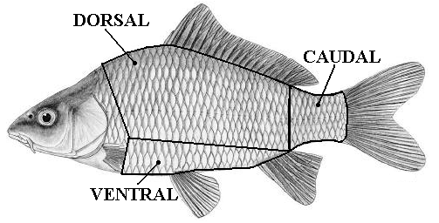
- Size/Age
- Growing quickly and to moderately large sizes, the common carp is said to reach weights in the 80-pound range, although the average ﬁsh is considerably smaller. The all-tackle rod-and-reel record is 75 pounds, 11 ounces. The maximum life span is disputed but may be a half century; the average carp seldom exceeds 15 years of age
.
HILSA
Scientific name: Tenualosa ilisha
Class: Actinopterygii
Family: Clupeidae
Phylum: Chordata
Higher classification: Tenualosa
Order: Clupeiformes

- The fish is marine; freshwater; brackish; pelagic-neritic; anadromous; depth range - 200 m. Within a tropical range.
- It can grow up to 60 cm in length with weights of up to 3 kg. It is found in rivers and estuaries in Bangladesh,
- and the It has no dorsal spines but 18 – 21 dorsal soft rays and anal soft rays. The belly has 30 to 33 scutes.
- There is a distinct median notch in the upper jaw.
- Gill rakers fine and numerous, about 100 to 250 on the lower part of the arch and the fins are hyaline.
- The fish shows a dark blotch behind gill opening, followed by a series of small spots along the flank in juveniles. Color in life, silver shot with gold and purple.
- The species filter feeds on plankton and by grubbing muddy bottoms.^{[6]} The fish schools in coastal waters and ascends up the rivers (anadromous) for around 50 – 100 km to spawn during the South West monsoons (June to September) and also in January to April.
- 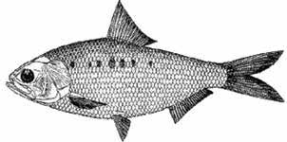
ANGUILLA
Scientific name: Anguillidae
Family: Anguillidae; Rafinesque, 1810
Clutch size: American eel: 500,000 – 4,000,000
Phylum: Chordata
- Adult freshwater eels are elongated with tubelike, snake-shaped bodies.
- They have large, pointed heads and their dorsal fins are usually continuous with their caudal and anal fins, to form a fringe lining the posterior end of their bodies.
- They have relatively well developed eyes and pectoral fins compared to saltwater eels that they use to navigate and maneuver through river bottoms and shallow water.
- Unlike most eels, freshwater eels have not lost their scales, and instead have soft, thin, scales that are embedded in the epidermis.
- Additionally, freshwater eels possess small, granular teeth arranged in bands on the jaws and vomer
- Anguillidae do exhibit size-dependent sexual dimorphism
- Male anguillids invest more energy into mating with as many females as he can, than they do into growth.
- Therefore, female anguillids are usually larger, ranging from 1.5 – 3 feet, while male anguillids rarely get larger than 1.5 feet long.^{[5]}
- Adult anguillidae can vary in color, but normally are brown, olive or olive-yellow, and can be mottled. Coloration matches the floor of rivers and lakes which prevents the eels from being seen by predators while in clear or shallow water.
- ^{[3]} Freshwater eels go through physical changes in their bodies when going to and from the ocean for different stages of life
- 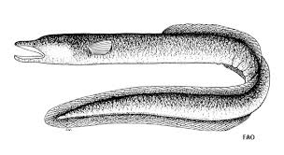
MEGALOPA CYPRINOIDES

Classification
- Kingdom Animaliaanimals
- Phylum Chordatachordates
- Subphylum Vertebratavertebrates
- Class Actinopterygiiray-finned fishes
- Order Elopiformes
- Family MegalopidaeTarpons
- Genu megalopa
- Species Megalops cyprinoides Bastard mullet

- In appearance, it is like the Atlantic tarpon, Megalops atlanticus: olive-green on top, and silver on the sides.
- The large mouth is turned upwards; the lower jaw contains an elongated, bony plate.
- The last ray of the dorsal fin is much longer than the others, reaching nearly to the tail. It is capable of filling its swim bladder with air and absorbing oxygen from it.
- Those living in fresh water tend to be smaller than the ones living in saltwater, growing just over 50 cm (20 in), while saltwater examples grow over 1 m (3.3 ft). They live upwards of 44 years and mature within two. They complete their metamorphosis from their larval stage in ten days.

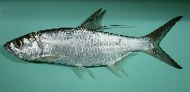

Eleutheronema tetradactylum

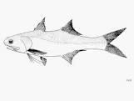
^{Kingdom:} ^{Animalia}
^{Phylum:} ^{Chordata}
^{Class:} ^{Actinopterygii}
^{Order:} ^{Perciformes}
^{Family :} ^{Polynemidae}
^{Genus:} ^{Eleutheronema}
^{Species:} ^{E. tetradactylum}

Dorsal spines (total): 9; Dorsal soft rays (total): 13-15; Anal spines: 3; Anal soft rays: 14 - 16; Vertebrae: 25.: second dorsal fin soft rays 14 (rarely 13 or 15) pectoral fin rays 16-18 (mode 17, rarely 15 or 19), pectoral filaments 4

; pored lateral line scales 71-80 (mode 73); scale rows above lateral line 9-12, below 13-15 (14); vomer with deciduous tooth plates on both sides, except in juveniles (< ca. 7.0 cm SL); posterior part of maxilla deep, 3-4% of SL; short tooth plate extension onto lateral surface of lower jaw, 7-9% SL.

Colour of upper sides of head and trunk with slight darkish silver tinge, becoming lighter in lower sides; anterior margins of first and second dorsal fins blackish, remaining parts translucent and slightly blackish, respectively; pectoral fin membranes vivid yellow in life, except in large specimens > ca 35 cm SL which is dusky yellow; pectoral filaments white; anterior margin of pelvic fin yellow and other parts white; base of caudal fin yellowish, other parts blackish
LATES CALCARIFER
- Dorsal spines (total): 7 - 9; Dorsal soft rays (total): 10-11; Anal spines: 3; Anal soft rays: 7 - 8.
- Body elongate; mouth large, slightly oblique, upper jaw extending behind the eye.
- Lower edge of preopercle serrated, with strong spine at its angle;
- opercle with a small spine and with a serrated flap above the origin of the lateral line.
- Caudal fin rounded
- Max length : 200 cm TL male/unsexed; common length : 150 cm NG male/unsexed; max. published weight: 60.0 kg Marine; freshwater; brackish; demersal; catadromous); depth range 10 - 40 m
Scomberomorus guttatus

lassification
- Kingdom Animaliaanimals
- Phylum Chordatachordates
- Subphylum Vertebratavertebrates
- Class Actinopterygiiray-finned fishes
- Order Perciformes
- Family ScombridaeMackerels, tunas, bonitos
- Genus Scomberomorus
- Species Scomberomorus guttatus Indian Spanish mackerel

- Gillrakers on first arch moderate: 1 or 2 on upper limb; 7 to 12 on lower limb; 8 to 14 total. First dorsal fin with 15 to 18 spines, usually 16 or more;
- second dorsal with 18 to 24 rays, usually 20 to 22, followed by 7 to 10 finlets; anal fin with 19 to 23 rays; followed by 7 to 10 finlets, usually 8; pectoral fin rays few, 20 to 23, modally 21.
- Lateral line with many fine auxiliary branches extending dorsally and ventrally in anterior third, gradually curving down toward caudal peduncle. Vertebrae 19 to 22 precaudal plus 28 to 31 caudal, total 47 to 52, usually 50 or 51.
- Intestine with 2 folds and 3 limbs. Colour: sides silvery white with several longitudinal rows of round dark brownish spots (smaller than eye diameter) scattered in about 3 irregular rows along lateral line.
- First dorsal fin membrane black (up to the 8th spine white posteriorly, with the distal margin black; pectoral, second dorsal and caudal fins dark brown; pelvic and anal fins silvery white.

Scomberomorus commerson

Classification
- Kingdom Animaliaanimals
- Phylum Chordatachordates
- Subphylum Vertebratavertebrates
- Clas Actinopterygiiray-finned fishes
- Order Perciformes
- Family ScombridaeMackerels, tunas, bonitos
- Genus Scomberomorus
- Species Scomberomorus commerson Barred mackerel

- Gillrakers on first arch few: 0 to 2 on upper limb; 1 to 8 on lower limb; 1 to 8 total.
- First dorsal fin with 15 to 18 spines, usually 16 or 17;
- second dorsal with 15 to 20 rays, usually 17 or 18, followed by 8 to 10 finlets; anal fin with 16 to 21 rays, usually 18 or 19 followed by 7 to 12 finlets, usually 9 or 10; pectoral fin rays 21 to 24.
- Lateral line abruptly bent downward below end of second dorsal fin. Vertebrae 19 or 20 precaudal plus 23 to 27 caudal, total 42 to 46.
- Intestine with 2 folds and 3 limbs.
- Colour: sides silvery grey marked with transverse vertical bars of a darker grey; bars narrow and slightly wavy, sometimes breaking up into spots ventrally; bars number 40 to 50 in adults but are usually fewer than 20 in juveniles up to 45 cm fork length; cheeks and lower jaw silvery white; first dorsal fin bright blue rapidly fading to blackish blue; pectoral fin light grey turning to blackish blue; caudal fin lobes, second dorsal, anal, and dorsal and anal finlets pale greyish white turning to dark grey.
- Juveniles have the anterior membranes of the first dorsal jet black contrasting with pure white posteriorly.
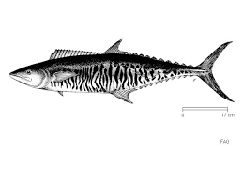
Rachycentron canadum

Classification
- Kingdom Animaliaanimals
- Phylum Chordatachordates
- Subphylum Vertebratavertebrates
- Class Actinopterygiiray-finned fishes
- Order Perciformes
- Family RachycentridaeCobia
- Genus Rachycentron
- Species Rachycentron canadum Black salmon

1 Colour dark-brown dorsally, paler brown laterally and white ventrally; black lateral band as wide as eye extends from snout to base of caudal fin, bordered above and below by paler bands; below this is a narrower dark band.
- Black lateral band very pronounced in juvenile, but tends to be obscured in adult.
- Body elongate, sub cylindrical; head broad and depressed. Mouth large, terminal, with projecting lower jaw; villiform teeth in jaws and on roof of mouth and tongue.
- First dorsal fin with 7-9 (usually 8) short but strong isolated spines each depressed into a groove, not connected by a membrane, 28-33 rays.
- Second dorsal fin long, anterior rays somewhat elevated in adults.
- Pectoral fins pointed, becoming more falcate with age.
- Anal fin similar to dorsal, but shorter; 1-3 spines, 23-27 rays.
- Caudal fin lunate in adults, upper lobe longer than lower (caudal fin rounded in young, the central rays much prolonged).
- Scales small, embedded in thick skin; lateral line slightly wavy anteriorly
- 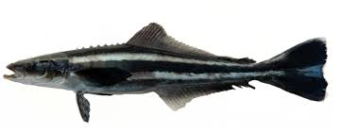
Stromateus argenteus
Scientific name: Pampus argenteus
Kingdom: Animalia
Family: Stromateidae
Class: Actinopterygii
Higher classification: Pampus
Phylum: Chordata
Order: Scombriformes
- Actinopterygii (ray-finned fishes) > Perciformes (Perch-likes) > Stromateidae (Butterfishes)
- Dorsal spines (total): 0; Dorsal soft rays (total): 37-43; Vertebrae: 34 - 37.
- Body firm, very deep, oval, and compressed.
- Operculum absent; gill opening reduced to a vertical slit on the side of the body; gill membrane broadly united to isthmus
- Dorsal and anal fins preceded by a series of 5 to 10 blade-like spines with anterior and posterior points. Pelvic fins absent.
- Caudal fin deeply forked, the lower lobe longer than the upper.
- Color is gray above grading to silvery white towards the belly, with small black dots all over the body. Fins are faintly yellow; vertical fins with dark edges.
- Maturity: L_{m} 25.3,
Max length : 60.0 cm SL male/unsexedcommon length : 30.0 cm SL male/unsexed;)

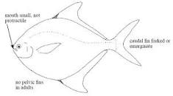

Etroplus suratensis

Classification
- Kingdom Animaliaanimals
- Phylum Chordatachordates
- Subphylum Vertebratavertebrates
- Class Actinopterygiiray-finned fishes
- Order Perciformes
- Family CichlidaeCichlids
- Genus Etroplus
- Species Etroplus suratensis Banded etroplus

Shape :-
- Body is very deep, short, oval and strongly compressed.
Depth of body is 55 % of SL (Standard length).
Eyes are large and placed laterally, eye diameter is 28.06 % of HL (Head length) .
Mouth is small and terminal .
Teeth are small and fine (villiform) and found in a single row at front but there are two or three rows at the back side in both jaw. There are no teeth on palate (roof of mouth).
Dorsal fin is inserted above pectoral fin base, with 18-19 spines and 14-15 soft rays. The spinous base is longer than soft rayed base.
- Soft Dorsal fin is pointed and reached just beyond the caudal fin base.
Anal fin has 12-13 spines and 11-12 soft rays. Soft Anal fin is pointed and reaches just beyond the caudal fin base.
Pelvic fins are located on thorax and have 16 rays.
Caudal fin is slightly concavely curved but not forked (emarginate).
Scales are weakly ctenoid and are of moderate size, they extend to the base of soft dorsal and anal fins. There are 35-40 scales in longitudinal series.
Lateral line is interrupted as in all cichlids.
- It has 6-18 scales after which it continues as small round hole in each scale.
- The upper lateral line is separated by 5 scales rows from dorsal fin base, and lower lateral line is separated by 17 scales from pelvic fin base.
A remarkable features of this family, is the development of the front part of the

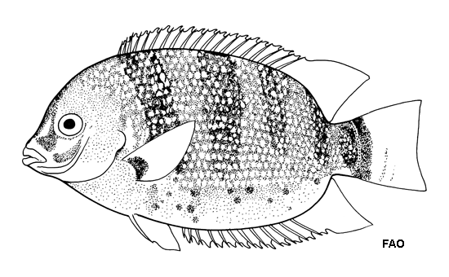
PISTIA

Identification:
Stem/Roots: Pistia stratiotes is a free-floating, herbaceous monocot with a rosette of gray-green leaves, resembling a head of lettuce (thus the common name), occurring as a single plant or connected to others by stolons.
Leaves: Leaves are ovate to obovate, up to 15 cm in length, without a leaf stalk, spongy near the leaf base, densely pubescent, with deeply furrowed parallel veins and wavy leaf margins
Flowers: Flowers inconspicuous, perfect, clustered in leaf axils with a single female flower and multiple male flowers
Fruit/Seeds: Produces abundant seeds with high percentage of seed viability 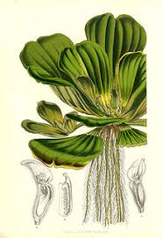

LEMNA
- Lemna species grow as simple free-floating thalli on or just beneath the water surface.
- Most are small, not exceeding 5 mm in length, except Lemna trisulca, which is elongated and has a branched structure.
- Lemna thalli have a single root, which distinguishes this genus from the related genera Wolffia (lacks roots), Spirodela and Landoltia (have multiple roots).
- The plants grow mainly by vegetative reproduction: two daughter plants bud off from the adult plant. This form of growth allows very rapid colonisation of new water.
- Duckweeds are flowering plants, and nearly all of them are known to reproduce sexually, flowering and producing seed under appropriate conditions.
- Certain duckweeds (such as L. gibba) are long-day plants, while others (such as L. minor) are short-day plants.
- When Lemna invades a waterway, it can be removed mechanically, by the addition of herbivorous fish (e.g. grass carp), or, inadvisedly, treated with a herbicide.
- The rapid growth of duckweeds finds application in bioremediation of polluted waters, in municipal wastewater treatment and as test organisms for environmental studies
- It is also being used as an expression system for economical production of complex biopharmaceuticals.
- 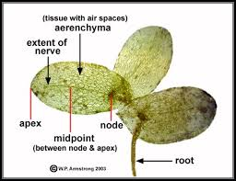

. Eichhornia crassipes
- monocot, perennial
- free-floating, except when stranded in the mud; mother plants and daughter plants attached by floating stolons
- leaves formed in rosettes rise to three feet above the water; leaves entire, ovate, rounded, circular, or broadly elliptic, to 6 in. wide; thick, glossy, waxy green, waterproof; sides gently incurved and often undulate; leaf base hearshaped, squared or rounded; veins dense, numerous, fine, longitudinal
- petioles (leaf stems) floating, creeping; inflated, bulbous, spongy, to 12 in. long
- multiple (8 to 15) flowers in a single very showy, spike (spathe) to 12 in. long; spike at top of erect thick stalk to 20 in. long, rising above the leaves; each flower in the flower-spike with six lavender-blue petals (perianths), petal tips slightly 2-lipped; uppermost petal somewhat larger, lavender, having a bright yellow, blue-bordered central oval splotch; stamens 6, stigmas 3
- roots hanging submersed beneath floating leaves, dark purplish to black, feathery, tips with long root caps
- fruit a capsule, 3-celled, with many seeds; seeds ribbed, formed in submerged, withered flower; fruit and seeds are rarely observed; seeds may produce many seedlings in moderate climates

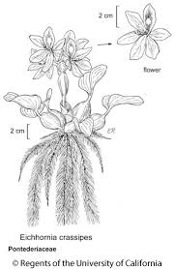

TYPHA

Typha are aquatic or semi-aquatic, rhizomatous, herbaceous perennial plants.
The leaves are glabrous (hairless), linear, alternate and mostly basal on a simple, jointless stem that bears the flowering spikes.
The plants are monoecious, with unisexual flowers that develop in dense racemes. The numerous male flowers form a narrow spike at the top of the vertical stem.
Each male (staminate) flower is reduced to a pair of stamens and hairs, and withers once the pollen is shed. Large numbers of tiny female flowers form a dense, sausage-shaped spike on the stem below the male spike.
In larger species this can be up to 30 centimetres (12 in) long and 1 to 4 centimetres (0.4 to 2 in) thick.
The seeds are minute, 0.2 millimetres (0.008 in) long, and attached to fine hairs. When ripe, the heads disintegrate into a cottony fluff from which the seeds disperse by wind
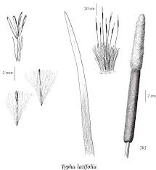
Nymphaea
- Water lilies are aquatic rhizomatous perennial herbs, sometimes with stolons, as well. The stem is angular and erect.
- The leaves grow from the rhizome on long petioles(stalk that attaches the leaf blade to the stem). Floating round leaves of waterlily grow upto 12 inches across
- . The disc shaped leaves are notched and split to the stem in a V-shape at the centre, and are often purple underneath.

- Most of them float on the surface of the water.
- The blades have smooth or spine-toothed edges, and they can be rounded or pointed.
- The flowers rise out of the water or float on the surface, opening during the day or at night.^{[2]}
- Many species of Nymphaea display protogynous flowering. The temporal separation of these female and male phases is physically reinforced by flower opening and closing, so the first flower opening displays female pistil and then closes at the end of the female phase, and reopens with male stamens.^{[5]}
- Each has at least eight petals in shades of white, pink, blue, or yellow. Many stamens are at the center.^{[2]}
- Water lily flowers are entomophilous, meaning they are pollinated by insects, often beetles.^{[2]}
- The fruit is berry-like and borne on a curving or coiling peduncle.^{[2]} Plant reproduce by root tubers and seeds
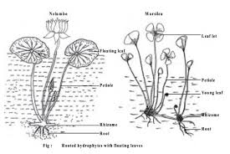

Utricularia
  - Most species form long, thin, sometimes branching stems or stolons beneath the surface of their substrate, whether that be pond water or dripping moss in the canopy of a tropical rainforest.
- To these stolons are attached both the bladder traps and photosynthetic leaf-shoots, and in terrestrial species the shoots are thrust upward through the soil into the air or along the surface.
- The name bladderwort refers to the bladder-like traps.
- The aquatic members of the genus have the largest and most obvious bladders, and these were initially thought to be flotation devices before their carnivorous nature was discoveredBladderworts are unusual and highly specialized plants, and the vegetative organs are not clearly separated into roots, leaves, and stems as in most other angiosperms.
- The bladder traps, conversely, are recognized as one of the most sophisticated structures in the plant kingdom 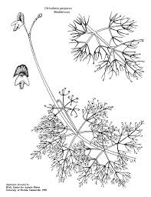

Marsilea
- is a genus of approximately 65 species of aquatic ferns of the family Marsileaceae. The name honours Italian naturalist Luigi Ferdinando Marsili (1656–1730).
- These small plants are of unusual appearance and do not resemble common ferns.
- Common names include water clover and four-leaf clover because of the long-stalked leaves have four clover-like lobes and are either present above water or submerged.
- The sporocarps of some Australian species are very drought-resistant, surviving up to 100 years in dry conditions.
- On wetting, the gelatinous interior of the sporocarp swells, splitting it and releasing a worm-like mass that carries sori, eventually leading to germination of spores and fertilization.

pomoea carnea,
- the pink morning glory, dhol kolmi in Bengali, is a species of morning glory.
- This flowering plant has heart-shaped leaves that are a rich green and 6–9 inches (15–23 cm) long.
- It can be easily grown from seeds which are toxic and it can be hazardous to cattle; the toxicity is related to the swainsonine produced by endophytes and to bioaccumulation of selenium species in leaves but mostly in seeds
- The stem of I. carnea can be used for making paper.
- The plant is also of medicinal value.
- It contains a component identical to marsilin, a sedative and anticonvulsant.^{[3]} A glycosidic saponin has also been purified from I. carnea with anticarcinogenic and oxytoxic properties.
- One selection of I. carnea, 'Inducer', has been used as a rootstock for inducing flowering of sweetpotato cultivars which otherwise prove reticent to produce flowers.
- Another common name is "bush morning glory", but particularly in temperate North America, that usually refers to I. leptophylla.

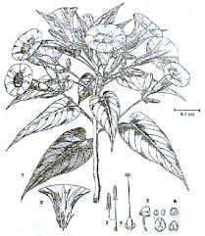

Jussiaea

- Herb with prostrate or ascending stems, rooting at the nodes, with conspicuous white erect fusiform mucronate pneumatophores arising in clusters at the nodes of the floating stems and from the roots;
- plants more or less densely villous to glabrous
- . Leaves 2–9 × 0·5–1·7(2·3) cm. on flowering stems, broader on floating non-flowering branches, dark green, shining, narrowly lanceolate to narrowly elliptical, narrowly cuneate at the base, the apex acute;
- main veins 6–12 on each side of the midrib; petioles 0·2–2 cm. long.
- , uniseriate in each locule of the capsule, pale brown, more or less vertical, firmly embedded in coherent cubes of woody endocarp 1·2–1·5 × 1–1·2 mm., the endocarp firmly fused to the capsule wall

5.Clarias Batrachus (Mangur):
Classification:
Phylum: Chordata
Subphylum: Vertebrata
Superclass: Pisces
Class: Teleostomi
Order: Cypriniformes
Family: Claridae
Genus: Clarias
Species: Batrachus
Distribution:
It is distributed through Pakistan, India, Nepal, Sri Lanka, Bangladesh, Myanmar, Indonesia, Kalimantan and the Philippines. It is widespread within India, both naturally and due to culturing. Its occurrence in South India is largely due to culturing.
Habit & habitat:
It is usually found in streams including tidal ponds, channels and flooded rice fields. Due to its ability to breathe in air directly, it can live in muddy water. It is found in hills also. They are voracious feedes & mostly stay buried in the muddy bottom. They are quite aggressive &inflict stings by their pectoral fins. Breeding occurs during the months of July to August in flooded rice fields. It attains maturity at the end of one year.
Comments:
1. The body is elongated with laterally compressed head.
2. Body colour is either uniformly reddish-brown or greyish black.
3. It may attain a maximum length of 45 cm.
4. Upper jaw is longer than the lower.
5. Head is sharpened superiorly and is covered with fin granules.
6. Barbles are of four pairs.
7. Dorsal fin is very long commences a little behind the occipital process and ends a bit anterior to the base of the caudal fin.
8. All the fins are covered with thick skin.
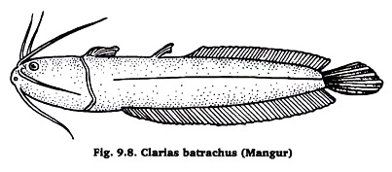
Economic importance:
It is very popular food fish and very economic in culture. Hence it is cultured extensively throughout India. The maximum yield can be obtained in experimental farms up to 50 tons. It fetches a good price. It is used as a laboratory animal for biological studies.

.

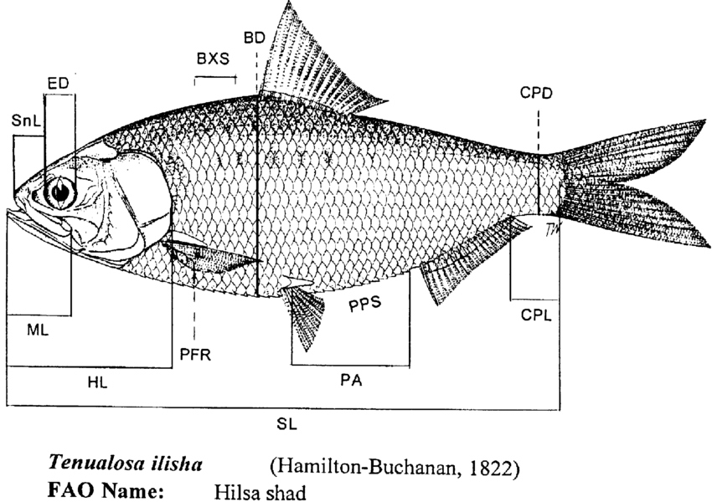Typha are aquatic or semi-aquatic, rhizomatous, herbaceous perennial plants.^{[5]:925} The leaves are glabrous (hairless), linear, alternate and mostly basal on a simple, jointless stem that bears the flowering spikes. The plants are monoecious, with unisexual flowers that develop in dense racemes. The numerous male flowers form a narrow spike at the top of the vertical stem. Each male (staminate) flower is reduced to a pair of stamens and hairs, and withers once the pollen is shed. Large numbers of tiny female flowers form a dense, sausage-shaped spike on the stem below the male spike. In larger species this can be up to 30 centimetres (12 in) long and 1 to 4 centimetres (0.4 to 2 in) thick. The seeds are minute, 0.2 millimetres (0.008 in) long, and attached to fine hairs. When ripe, the heads disintegrate into a cottony fluff from which the seeds disperse by wind.It is a perennial monocotyledon with thick, soft leaves that form a rosette. It floats on the surface of the water, its roots hanging submersed beneath floating leaves. The leaves can be up to 14 cm long and have no stem. They are light green, with parallel veins, wavy margins and are covered in short hairs which form basket-like structures which trap air bubbles, increasing the plant's buoyancy. The flowers are dioecious, and are hidden in the middle of the plant amongst the leaves. Small green berries form after successful fertilization. The plant can also undergo asexual reproduction. Mother and daughter plants are connected by a short stolon, forming dense mats.It is a perennial monocotyledon with thick, soft leaves that form a rosette. It floats on the surface of the water, its roots hanging submersed beneath floating leaves. The leaves can be up to 14 cm long and have no stem. They are light green, with parallel veins, wavy margins and are covered in short hairs which form basket-like structures which trap air bubbles, increasing the plant's buoyancy. The flowers are dioecious, and are hidden in the middle of the plant amongst the leaves. Small green berries form after successful fertilization. The plant can also undergo asexual reproduction. Mother and daughter plants are connected by a short stolon, forming dense mats.It is a perennial monocotyledon with thick, soft leaves that form a rosette. It floats on the surface of the water, its roots hanging submersed beneath floating leaves. The leaves can be up to 14 cm long and have no stem. They are light green, with parallel veins, wavy margins and are covered in short hairs which form basket-like structures which trap air bubbles, increasing the plant's buoyancy. The flowers are dioecious, and are hidden in the middle of the plant amongst the leaves. Small green berries form after successful fertilization. The plant can also undergo asexual reproduction. Mother and daughter plants are connected by a short stolon, forming dense mats.It is a perennial monocotyledon with thick, soft leaves that form a rosette. It floats on the surface of the water, its roots hanging submersed beneath floating leaves. The leaves can be up to 14 cm long and have no stem. They are light green, with parallel veins, wavy margins and are covered in short hairs which form basket-like structures which trap air bubbles, increasing the plant's buoyancy. The flowers are dioecious, and are hidden in the middle of the plant amongst the leaves. Small green berries form after successful fertilization. The plant can also undergo asexual reproduction. Mother and daughter plants are connected by a short stolon, forming dense matsIt is a perennial monocotyledon with thick, soft leaves that form a rosette. It floats on the surface of the water, its roots hanging submersed beneath floating leaves. The leaves can be up to 14 cm long and have no stem. They are light green, with parallel veins, wavy margins and are covered in short hairs which form basket-like structures which trap air bubbles, increasing the plant's buoyancy. The flowers are dioecious, and are hidden in the middle of the plant amongst the leaves. Small green berries form after successful fertilization. The plant can also undergo asexual reproduction. Mother and daughter plants are connected by a short stolon, forming dense matsBottom of Form

